**Objective:**

The main objective of this proof of concept is to introduce SOAP UI for functional testing automation for testing SOAP and REST web services for Data Diagnostics (DDx).

**Data Diagnostics:**

Data Diagnostics is a suite of hundreds of patient-specific data analyses that can be ordered individually on demand by clinicians at the point of care within their existing workflow. The solution helps clinicians identify and address gaps in quality, risk, utilization and medical history insights, supporting improvement in the clinical and quality outcomes and financial performance across the healthcare community in real time.

**Acronyms:**

XML - Extensible Markup Language

WSDL - Web Service Definition Language

SOAP - Simple Object Access Protocol

UDDI - Universal Description Discovery and Integration

REST - Representational State Transfer

WADL - Web Application Description Language

CRUD- Create Retrieve Update Delete

PGPD- Post Get Put Delete

**SOAP & REST Overview:**

* There are many web service types and following two are widely being used in the current market trend

**SOAP (Simple object access protocol) Service**

* It allows only XML data format and uses WSDL
* Standardized specifications and suits for enterprise applications
* Language, platform, and transport independent
* Build in error handling and security specs

**REST (Representation state transfer) Service**

* Different data formats can be used and it uses WADL
* Light weight and less complex for maintenance
* It follows the stateless model and uses HTTP/HTTPS for transfer
* Uses HTTP standard methods like (GET, PUT, POST, DELETE)

**Protocol Stack:**

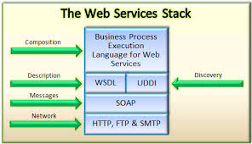

**Context:**

**Recommended State**

**Current State**

**Recommended State**

* Complete automation suite to test the future release testing.
* Comprehensive automation test suite.
* Reduced test cycle time.
* Reduced testing cost.
* Accelerated and efficient business needs.
* Reduce manual efforts and errors.
* Cross browser testing through automation.
* DDX consists of three API’s two SOAP API’s and one REST API.
* Higher testing cost.
* Higher test cycle time
* Content and text verification done manually across browsers

**Comparison:**

|  |  |  |
| --- | --- | --- |
| **Tools/Criteria** | **HP QTP/UFT** | **SOAP UI** |
| Cross Platform | Windows only | Windows XP and later |
| Application support | Client server applications, Mobile applications | Web applications as well as Client server applications |
| Browsers-support | IE-Firefox-Chrome | IE-Firefox-Chrome |
| Record-Playback | Support | Support |
| Ease of Use | Easy to learn in a short time | Easy to learn in a short time |
| Script-language. | VBScript | Groovy or JavaScript |
| Data-Driven Framework | Excel files, text files, XML, DB files | Excel files, XML, JDBC |
| Debugging support | Strong | Strong |

**SOAP UI:**

SoapUI is a web service testing application for service-oriented architectures (SOA) and representational state transfers (REST). Its functionality covers web service inspection, invoking, development, simulation and mocking, functional testing, load and compliance testing.

SoapUI is a cross-platform functional testing solution. In a single test environment it provides SOAP- and REST-based Web services, to JMS enterprise messaging layers, databases, Rich Internet Applications, and much more. It is built entirely on the Java platform and uses Swing for the user interface. It also supports IDEA, Eclipse and NetBeans. SoapUI is licensed under the EUPL. It is an open-source tool but there is also a commercial version, SoapUI Pro, which mainly focuses on features designed to enhance productivity.

**Why SOAP UI PRO:**

1. SoapUI NG Pro gives the complete functional testing capability for SOAP API, REST and other protocols

4. It allows ad-hoc testing or command line interface to test our APIs effectively.

5. All the REST, SOAP API and other service components can be used by simply drag and drop method

6. In SoapUI NG Pro, data driven feature is little enhanced in retrieving information from external data sources for example, excel, XML, JDBC data sources and file / directories etc.

7. We can transfer the property test step values to xpath-queries, scripts and so forth.

8. SoapUI NG Pro offers the feature called point-and-click to generate test scenarios quickly

9. SoapUI NG Pro allows the end user to customize their services easily even they are new to SoapUI Pro or development experience.

10. Few more important features available in SoapUI NG Pro:

* Test Coverage: To analyze the API tests along with the functionality as expected
* Multi-environment Support: Allows to change the testing environment based on our requirements
* Test Debugging: This feature helps to analyze the test step-by-step debugging. It also includes variables, properties, input requests etc.
* Complex Scenarios: SoapUI NG Pro makes it easier the APIs which are involved in client server architecture
* Drag and Drop Test Creation: As it exists, it is easy to create and run the test scenarios by drag and drop feature

**Soap UI vs Soap UI Pro:**

|  |  |  |
| --- | --- | --- |
| **General features** | **SoapUI** | **SoapUI NG Pro** |
| Standalone Application | checked | checked-orange |
| IDE Plugins | checked |  |
| WebStart | checked | checked-orange |
| Tabbed Desktop |  | checked-orange |
| Groovy Code Templates |  | checked-orange |
| Workspace Management | checked | checked-orange |
| Multi Environment Support |  | checked-orange |

|  |  |  |
| --- | --- | --- |
| Functional Testing features | SoapUI | SoapUI NG Pro |
| WSDL Coverage |  | checked-orange |
| Request/Response Coverage |  | checked-orange |
| Message Assertion | checked | checked-orange |
| Test Refactoring |  | checked-orange |
| REST Discovery |  | checked-orange |
| Dynamic Data Generation |  | checked-orange |
| Drag and Drop Test Creation | checked | checked-orange |
| Running of Multiple Tests | checked | checked-orange |
| Maven Integration | checked | checked-orange |
| Standalone Server Runners | checked | checked-orange |
| Scripting Support (Groovy, JavaScript) | checked | checked-orange |
| Scripting Libraries |  | checked-orange |
| Requirements Management |  | checked-orange |
| Advanced Reporting |  | checked-orange |
| Tree Based input for easy manual testing |  | checked-orange |
| Create Test from Web Service Recordings | checked | checked-orange |
| WS-Security Support | checked | checked-orange |
| WS-I Integration | checked | checked-orange |
| Manual TestStep | checked | checked-orange |
| Test Debugging |  | checked-orange |

**Connecting with our project:**

**Test Case - SOAP API:**

WebService Name          Middle Tier

WebService protocol      SOAP

Tier                                     UAT

Endpoint                            <http://datadiagnosticsservicesuat.apps.inovalon.com/PatientDiagnostics.svc>

Operation                          GetPatientDiagnostics

**Executing Test case and Test Step:**

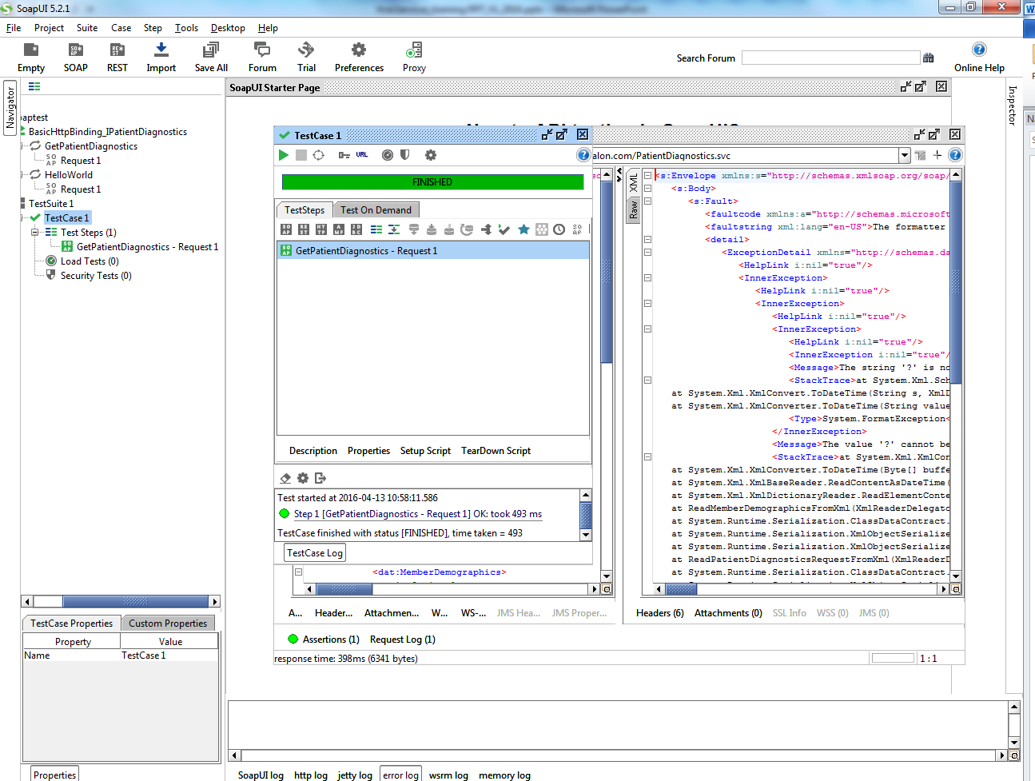

**Reporting:**

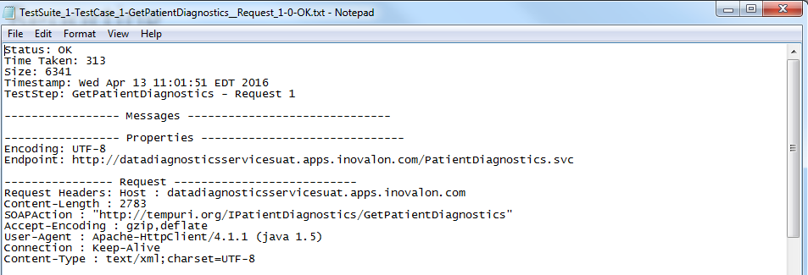

**Test Case- Rest API:**

WebService Name          Analytics / Data Diagnostics

WebService protocol      REST

Tier                                     UAT

Endpoint                            <http://ddwsvmuatapp1>

Resource                           /avalon/data/get_member_data

Method                             Get_member_data

**Executing Test case and Test Step:**

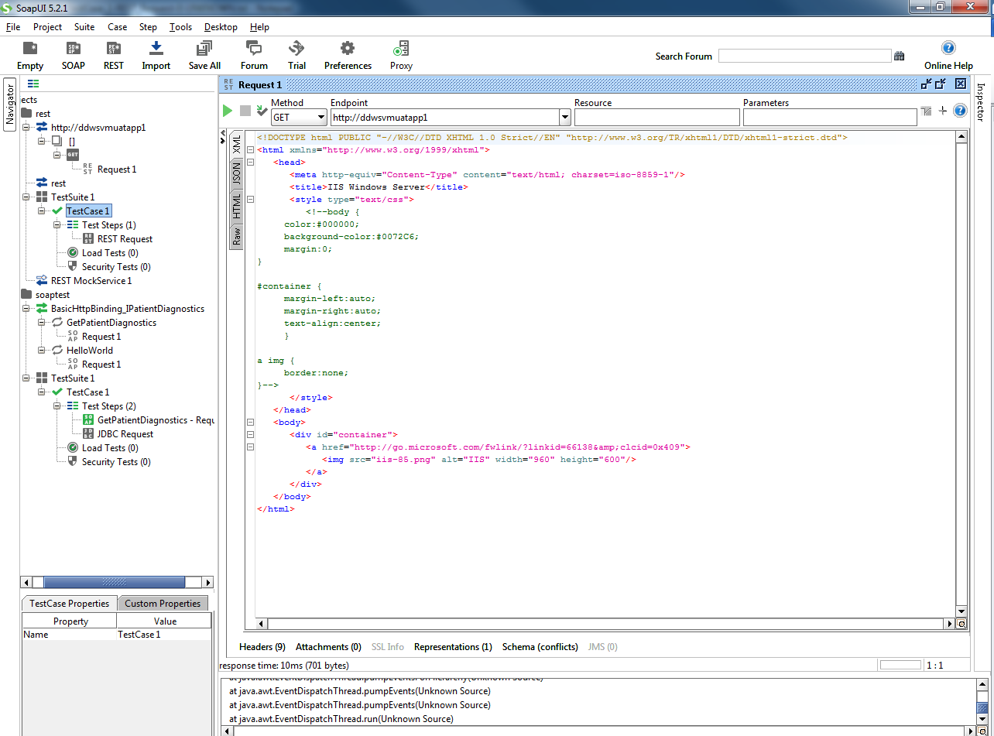

**Reporting:**

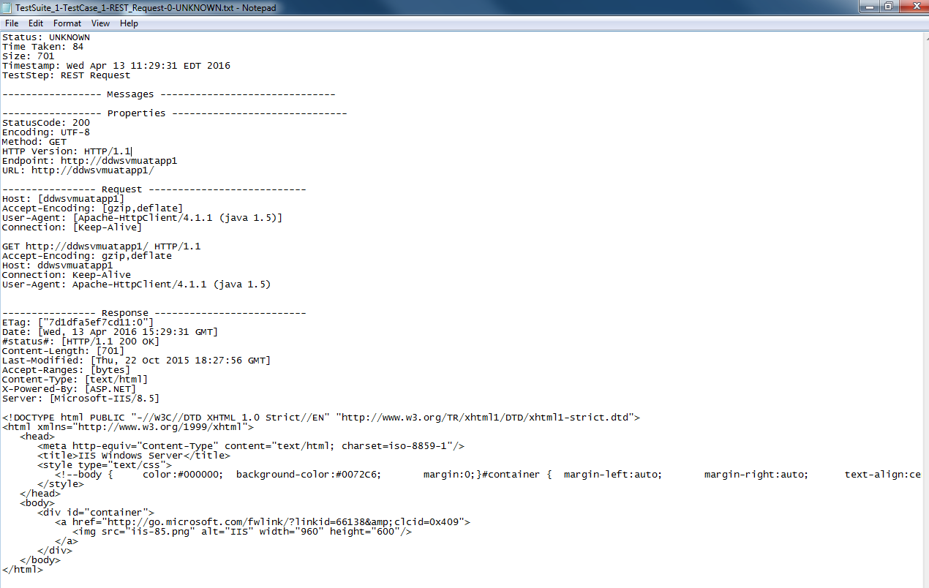

**Assertions:**

Assertions are used to validate the message received by a Test Step during execution. Any number of assertions can be added to a Test Step. After a Test Step executes, all its assertions are applied to the received response and if any of them fail the Test Step is marked as failed in the Test Case view.

**Groovy in SOAPUI:**

Groovy is an agile dynamic language for the Java Platform with many features that are inspired by languages like Python, Ruby and Smalltalk, making them available to developers using a Java-like syntax.

**Data Driven Testing:**

Data-driven testing is when test data (input, expected output, etc) is stored in some external storage (database, spreadsheet, xml-files, excel sheet etc) and then this data is used iteratively in tests while running.

**JDBC Request:**

JDBC request is used to run database queries directly from SoapUI. The Query results can be viewed in XML format in the response window. JDBC connection can be setup at project level as well as at test step level.

**Automation Approach:**

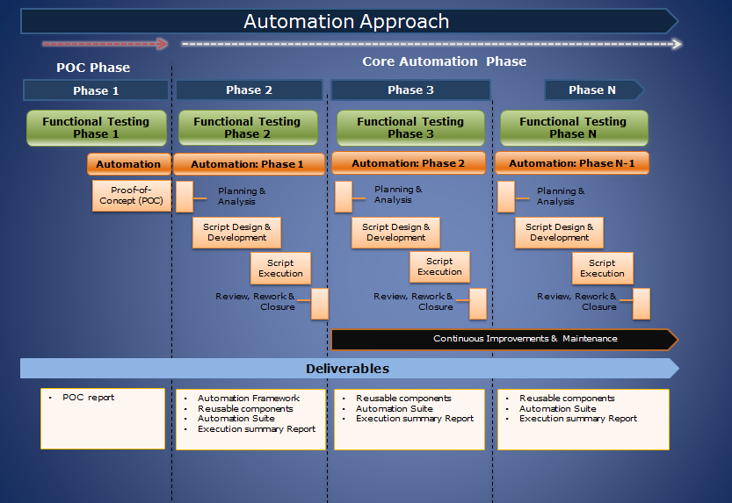

**Implementation Roadmap:**

Implementation

Testing Activities

* Technical overview of the application
* Access privileges
* Feasibility analysis of the application
* Identify Manual Functional Test cases for automation
* Developing reusable functions
* Developing application specific functions

Design new test scripts using Groovy and Javascript

**Existing Functional Test Cases**

On Boarding Process and KT

Setup Environment & Tool Configuration

Run the test scripts

Review and approve the test scripts

Automation Activities

**Pricing:**

Soap UI Pro

* SoapUI NG Pro – Floating License – 3,490 USD.